New German Highway Infrastructure and the Impacts on
Residential Real Estate Prices

Jeffrey P. Cohen
Professor, Center for Real Estate and Urban Economic Studies, University of Connecticut
Visiting Researcher, FDZ-Ruhr at RWI-Leibniz Institute for Economic Research
Jeffrey.Cohen@uconn.edu

Sandra Schaffner
FDZ-Ruhr at RWI-Leibniz Institute for Economic Research
Sandra.Schaffner@rwi-essen.de

September 1, 2020

Abstract: The German Autobahn highway A38, connecting the east and west, was completed in 2009 and expanded through 2013. The highway completion/additions alleviated congestion, and enhanced connectivity in the mainly rural areas. We use hedonic house price models to test the hypotheses of positive price effects, and of negative noise/pollution effects, from the A38. We focus on two separate neighborhoods – one near a major highway extension, off of the A38, and another on a separate local road that saw greater traffic before the opening of a nearby segment of the A38. We use a German residential real estate dataset spanning 2007-2017. Our identification strategy is based on the Lewbel (2012) approach, which relies on heteroscedasticity. Our results support the hypotheses that properties with shorter drive times to the A38 highway exhibit higher prices; and properties near the A38 have lower prices after controlling for drive time. A robustness experiment compares the Lewbel estimates with quasi difference-in-differences estimates, and the former are up to 50% larger than the latter, likely due to data availability starting after the announcement dates. This implies more generally that the Lewbel approach could be a viable alternative to quasi diff-in-diff when pre-announcement date data are unavailable.

Keywords: Real Estate Prices, Highways, Germany
JEL Codes: R3, R4

Introduction and History

Highway access has long been an essential component of the economies of thriving cities within Western countries, and in turn, their benefits and drawbacks are expected to be capitalized into real estate values. Better highways make remote locations more accessible to jobs and therefore should enhance residential real estate prices nearby. On the other hand, there is additional noise and pollution that often accompany highway proximity, so in some cases the overall effect might be ambiguous. The primary objective of this paper is to test the hypotheses that access to a new highway in Germany led to higher residential real estate prices; and the associated negative effects such as noise and air pollution led to lower real estate prices.

Recent research on real estate and highway infrastructure in other countries recognizes there may be such a relationship, and this can inform policy when new highway investments are being considered. But this is not the way it always has been, particularly in Germany. For instance, in the 1930’s Germany built a sophisticated highway network, primarily as a means to transport its military equipment and troops throughout the country and easily reach neighboring countries, and as a way to create construction jobs “partly to alleviate the serious unemployment problem among millions of hungry Germans” (Guthrie, 1949). Today, German highways are crucial for transporting goods, and for people commuting from rural areas to cities to access employment opportunities from their place of residence.

One way to measure the value residents place on highway proximity is with a hedonic housing price model, as in Rosen (1974). Such an approach can help determine how real estate markets assign value to highway proximity. There are several possible identification strategies, including the Lewbel (2012) approach that relies on heteroskedasticity; and separately, a quasi-difference-in-differences (diff-in-diff) approach. The Lewbel (2012) approach is the primary method we use to identify causal relationships between highways and real estate prices, and we also use quasi differences-in-differences as a robustness check. To our knowledge, the Lewbel (2012) approach has not been applied to address the question of how highway infrastructure impacts house prices; it may also be a viable alternative to difference-in-differences when pre-announcement date data are not available. There is also little empirical evidence demonstrating the causal impacts of highways on residential real estate prices in Germany.

Collecting German real estate price data back to the initial construction (and/or the announcement) of the first highways in the 1930’s or earlier is infeasible. In general, there is limited data available on residential German real estate prices; typically the German data are available from 2007 onward. Even when considering only one more recent, specific highway infrastructure improvement, pre-announcement date real estate prices data are not available. We conjecture that the Lewbel (2012) approach is a viable alternative solution to this problem. One reason is that the Lewbel (2012) approach does not rely on a before vs. after analysis. But focusing on the Lewbel (2012) approach with a relatively new highway can help one understand the impacts of this new highway on real estate.

The German A38, which was built in 2009, and expanded with additional interchanges through 2013, has been crucial in connecting East and West Germany. The A38 gives workers the opportunity to commute to Leipzig (in the East) or Gottingen (in the West), which are at the ends of the highway (see Figure 1 for the route of the road). It also enables firms to ship products more quickly along this corridor. This highway improvement was expected to impact the values of real estate nearby. This is an important part of the Autobahn because it enables people in the east to access job opportunities in the west and vice versa, among other benefits. Before reunification only very few border crossings between GDR and FRG were in operation. Therefore, there was a lack of connections between East and West Germany. Further, the former GDR invested nearly nothing in road infrastructure from the 1970s onward. This discrete improvement in highway infrastructure in the East was expected to increase residential real estate prices as it would enable the east to become much more inhabitable, along with eased noise and congestion on nearby local roads that were previously relied upon but at a much slower travel speed.

The highway A38 is part of the “traffic project German union” (Verkehrsprojekt Deutsche
Einheit). This project was implemented to improve the connection between East and West Germany as well as the quality of highways in the east. The aim of the highway A38 is, together with the A7 and A44, to connect the Leipzig/Halle region in the east with the Ruhr area in the west and to reduce the traffic on the A2. The different parts of the A38 highway were opened at different points of time. The last part was opened on December 22nd, 2009. However, additional motorway interchanges were opened in 2011 and 2012. The opening of the different parts of the highway did not follow from west to east, from east to west, or from the outside to the middle. Rather, it was opened piecewise so that there were still missing links in 2008. One of these gaps of about 12 km was in the West (Breitenworbis to Bleicherode, see Figure 4 for the route). Until the opening along this gap in December 2009, the traffic of the highway was directed on rural and county roads that are more or less parallel to the planned A38 (including the need to travel on the L2070 south to the L3080 west, in a very circuitous route). In addition to the increased travel time due to the longer distance to reach the A38, these local roads were narrower and prevented high speed travel.

These small roads still exist and go through villages and towns. Therefore, the residents who lived very close to these roads were affected by a lot of noise and pollution due to the traffic, especially since many trucks already used the A38 and therefore instead had to drive on these alternative roads. Additionally, there might have been positive economic effects of the traffic since the drivers probably consume goods when they use the highway, because they could stop in these villages.

Besides the gaps that were closed at the A38 highway, it was also extended by new interchanges. On December 5th, 2012 the exit “Großwechsungen” (Figure 5) was opened that connects the A38 to the state road B243 that goes to the Northwest. Due to this connection, more villages and towns can be reached faster from the A38.

The completion of various sections of the A38 highway in 2009 provides the basis for analysis that can identify the impacts of the highway on real estate prices, along with the effects on real estate prices of proximity to other new roads that were built to connect with several segments of the A38. We focus our analysis on one of the alternative roads that were formerly used as primary driving routes between the east and west but were subsequently replaced by the A38; and on one A38 highway extension segment. We use a German dataset on owner-occupied real estate prices, based on properties listed for sale in Germany during the years 2007-2017.

Using the Lewbel (2012) approach as our identification strategy, we find prices are higher for those in shorter driving distance to this extension of the A38. On the other hand, after controlling for driving distance, properties that are close to the A38 extension (“as the crow flies”) tend to have lower prices, which we attribute to traffic noise and congestion. We also find evidence that sales prices are lower for those in close proximity to the alternative road, which implies those neighborhoods perhaps became less desirable after the opening of the new highway extensions. We consider a set of robustness checks for these Lewbel (2012) estimates by using a quasi diff-in-diff approach. One major difference between the Lewbel (2012) approach and the quasi diff-in-diff is that the former identifies the causal effect using data for properties for sale after the opening of the extensions of the A38, while the latter relies on a pre/post analysis to estimate a treatment effect. For properties listed for sale, the most significant effects of the highway are evident when the quasi diff-in-diff treatment considered is post-2009, within 15 minutes driving of the nearest exit to the A38. The treatment effect of approximately 11%-20% is quite robust to various specifications for cross-sectional fixed effects, and standard errors are clustered based on labor market commuting zones. On the other hand, the Lewbel (2012) estimates are in the range of approximately 30% higher prices due to proximity, which is also robust to alternative model specifications. We attribute the discrepancies to the fact that in this specific application, the data available only allow the quasi diff-in-diff approach to capture the opening effect rather than the announcement effect. In contrast, the Lewbel (2012) approach captures all of the proximity benefits because it does not rely on a before vs. after analysis. Therefore we would expect, in this specific application, that the Lewbel (2012) estimates should be higher than the quasi diff-in-diff estimates. Regardless, the present discounted value of the expected highway benefits over a relatively long-time horizon are reflected quite strongly in owner-occupied properties.

In the remainder of this paper, we first review the literature on how proximity to highways may impact real estate values. We also discuss other recent studies of highways using German data. Then we provide an overview of the data and the econometric approach to identifying the causal effects of the A38 highway on real estate prices in Germany, followed by a discussion of the results. A conclusion section summarizes the key findings and potential usefulness of the results for policy makers.

Literature Review

There are many studies of highway impacts for the U.S. and for other countries, but hedonic housing prices studies with rigorous identification strategies have been emerging within the last decade. In the context of German highways, Möller and Zierer (2018) instrument the Autobahn networks using plans for the Autobahn from the 1930’s and plans for rail networks from the 1800’s, and observe positive causal effects of German highways on regional employment and wages. Specifically, they find that for a one standard deviation in the length of the Autobahn, both employment and the wage bill for local employees increased by around 3 percent during the period of 1994-2008.

There are several German housing price studies that utilize the RWI-GEO-RED dataset (that we use in this study), or other older data from sub-sections of Germany that is based on the platform ImmobilienScout24. Except for one of these studies, none of them consider the Autobahn (and that Autobahn study only examines correlations between proximity to the highways and residential real estate prices).

Bauer et al (2017) consider the natural experiment of a German nuclear power plant’s sudden closing due to the Fukushima nuclear disaster, using the RWI-GEO-RED data. They find this sudden closure decreased real estate prices nearby by around 10% in the short-term.

There are some studies of German transportation infrastructure impacts on real estate prices (although only a small number of these use RWI-GEO-RED or similar). For instance, Schulz and Werwatz (2004) find that Berlin house prices are more than 26% lower if they are near a rail line, highway, or airport. But they do not distinguish between these different types of infrastructure in their analysis. Ahlfeldt (2011) finds that rail station proximity has no significant effect on house prices in Berlin.

Among studies of German real estate and transportation using ImmobilienScout24 data, there is Brandt and Maennig (2012). These authors find that proximity to rail and public transit in Hamburg has an overall effect of raising property list prices by 4.6%, while effects of proximity to underground stations is somewhat higher.

Liebelt et al. (2018) examine the correlations between proximity to urban green space and house prices in Leipzig, Germany. While their main focus is on urban green space, they also include controls for distances from the nearest “large road” and “municipal road”. For every meter further closer to the nearest large road, list price of houses falls by 0.39 Euros, and for rental apartments, for every meter closer to the nearest large road, rental prices fall by 0.001
Euro. But for “municipal roads” the signs are the opposite from large roads – the effect of being one meter closer to the nearest municipal road raises house prices by 0.22 Euros, while for apartments being one meter closer to a municipal road raises rental prices by 0.001 Euro. Their focus on Leipzig is the endpoint of the A38 on the eastern end of the highway, which is of direct interest to our study. However, their estimation approach implies correlation between proximity to the nearest large road and proximity to the nearest municipal road, but not causality. Our major contributions are the focus on the Lewbel (2012) approach to identify the causal relationship between the A38 and residential real estate prices; and exploration fo how the difference-in-differences approach to the quasi-experiment of the opening of the A38, in the broader context than in just one German city, might be inferior to the Lewbel approach when pre-announcement date housing prices data are unavailable.

In the European context, Levkovich et al. (2016) examine how house prices are impacted by newly constructed highways in the Netherlands, with a diff-in-diff approach as their identification strategy. They estimate noise by “as-the-crow-flies” distance from each property to the highways. They find a tradeoff between accessibility with the new highways, and noise pollution due to proximity to the highway. In our approach, we consider these types of tradeoffs in a similar manner, and in addition to the diff-in-diff approach, we also apply the Lewbel (2012) methods that are not reliant on a specific event date. We also incorporate two separate proximity controls – one “as-the-crow-flies” to isolate the noise impacts, and a separate control for driving distance to control for the accessibility effect.

Data

Figure 1 is a map of the location of the A38 in Germany. On the east side of the A38, it runs on the south end of Leipzig (former GDR), and moves west for approximately 100 km. The west side of the A38 terminates south of Gottingen and east of Kassel (former FRG). Before the opening of the A38, there were far fewer options for commuters to travel from the east to the west in this region of Germany. It is evident from this map that there are no viable alternative highways for driving between the east and west of this section of Germany.

For the real estate data, we use the property-level RWI-GEO-RED dataset (located and maintained by RWI), which has coverage for all of Germany from 2007-2017. The actual coordinates of each property are not available, but location variables for each property are based on the centroid coordinates of the 1km by 1km grid in which each property is located. The lowest levels of aggregation available for locations of each property are these grids, due to the need to preserve confidentiality. Figure 2 demonstrates the numbers of owner-occupied houses for sale in each grid throughout Germany during the sample period, with the location of the A38 highlighted in green. There is apparent density of both houses and apartments in Leipzig, as well as small pockets in various locations along the central portion of the A38. Slightly beyond the western end of the A38, the highway terminates approximately 15 km driving distance from both Kassel and Gottingen, which have substantial residential density of properties that were listed for sale between 2007 and 2017. Figure 3 shows the average residential real estate price in each grid throughout Germany during the period 2007-2017.

Drive times to the nearest A38 highway exits are based on actual latitude/longitude for each highway exit, and the latitude/longitude of each property. Drive times from each dwelling to the actual location of the nearest exit of the A38 are obtained from OpenStreetMap. These drive time calculations are based on the average speed on the local motorways, e.g. on a motorway this would be 90 km per hour (defaults at OpenStreetMap). These drive times from each grid to the A38 are joined with the data for properties located in each grid, to get an approximate drive time from each property (i.e., the grid in which each property is located) to the nearest exit of the A38. Figure 6 shows the A38, the locations of the homes for sale during our sample period, and the drive time (in meters) from each property to the nearest exit of the A38. Figure 7 shows the same homes with their “as-the-crow-flies” distance to the A38, which is a proxy for the extent of pollution exposure for each home.

As additional control variables we take the average age of residents within the 1km² neighborhood from the RWI-GEO-GRID data set (RWI and microm 2018). A detailed data description can be found in Breidenbach and Eilers (2018). This data covers information on the population for all Germany for the years 2005 and 2009 to 2016. We define three age groups and their share at the whole population: kids (age 0 to 18), young age (18-29) and elderly (60 and above).

For the quasi diff-in-diff robustness check, we define the date of the treatment of each intervention, separately, by the month the respective part of the A38 was completed. For the driving time from each property to the nearest exit on the A38, the most significant treatment effects occur for less than 900 seconds (15 minutes) in the sales sample. Further, we have enough observations in the treatment group which is not the case for shorter driving times. Therefore, we define the sales treatment group as those properties that sold after the respective completion within 900 seconds (15 minutes) driving to the A38.

The section of the A38 shown in Figure 4 (highlighted blue) was opened in December 2009, before which the B80 (highlighted in red) was used instead. There were trucks driving through small villages, and the opening of this section of the A38 eliminated truck noise and some pollution. There were some effects for residents living near this road because of the benefit from highway access as well as the additional benefit of fewer trucks in the villages after the opening of this section of the A38 while their connection to the A38 is still there.

Figure 5 shows the B243 (highlighted blue) that opened in December 2012, which connects to a section of the A38. Prior to the opening of the B243, residents next to this local road had much less convenient access to the A38. There are several hundred real estate observations in our sample for this area.

In all of Germany between 2007-2017, there are 4,341,107 properties listed for sale, with an average log price per square meter of 7.312 Euros (Table 1). The average property is 36.4 years old (where age is defined as difference between date of listing and date of construction completion), and approximately 15.8% of the properties are the first occupancy. The average lot size is 639 square meters, and 52.2% of the sales properties are single family houses. The federal state with the highest percentages of the sales is North Rhine-Westphalia (approximately 24.4%), followed by Lower Saxony (approximately 12.3%). Both 2008 and 2009 had about 11% of the total sales, followed by approximately 10% of the sales in 2010. The subsequent years each had about 9% or fewer of the total number of sales. Figure 3 is a map of the list prices for properties in Germany during the sample period of 2007-2017. There is substantial variation in the prices of houses near the A38, as well as throughout all of Germany.

Since the RWI-GEO-RED data available are individual properties listed for sale at various points in time, they do not comprise a panel dataset. RWI-GEO-RED has information on the list price of individual properties for sale at a given point of time, between the years 2007-2017, for the entire country of Germany.⁷ Figures 6 and 7 demonstrate the locations of nearby properties for sale during the period 2007-2017. The route of the A4 is also shown in Figures 6 and 7. Figure 6 shows the drive time to the nearest exit on the A38, while Figure 7 shows the Euclidean distance between each property and the nearest point on the A38. Finally, it is noteworthy that properties near the A4 have much shorter drive times to the A38 than other properties with similar Euclidean distances to the A38 as those near the A4, which underscores the importance of the German highway network.

Approach

We rely on the Lewbel (2012) identification strategy to test the hypotheses on accessibility and noise effects of the A38. The Lewbel (2012) approach is modelled as follows:

Y_{1i} = X_{i}'β + Y_{2i} γ + ε_{1i} (i)

Y_{2i} = X_{i}'α + ε_{2i} , (ii)

For each empirical model (i.e., the model for properties near the “previous street” and the model for properties near the “highway extension”), we consider two alternative measures of distance. One of these is a continuous distance variable, and another is an indicator for within 2000m. In equations (i) and (ii) above, we define Y_{1i} as the house i price, Y_{2i} is a matrix with 2 elements, including the distance from house i to the “street”, and distance from the house to the A38 (or alternatively, an indicator variable for within 2000m); X_{i} is a vector of exogenous variables for house i (including a constant term), ε_{1i} and ε_{2i} are error terms for house i, and β, γ, and α are parameters to be estimated.

To provide some intuition, when Y_{2i} is the distance to the A38 from an individual property, one hypothesis is that we expect the distance to the A38 to impact newly listed house prices. But newly listed house prices have no impact on the distance to the A38 (since the decision of where to locate the A38 was already completed at the time of the sale listings of all the properties under consideration with the Lewbel approach). The equation (ii) implies a hypothesis that the location of the A38 relative to property i depends on the property i characteristics (i.e., the X's - bedrooms, bathrooms, square meters, age, etc). Since in most if not all cases the property was built long before the location decision for the A38, those characteristics were in place before the A38, so perhaps the German government decided to build the A38 near "older" houses or houses with fewer bedrooms, bathrooms, etc. But the listing price in 2015, for instance, had no impact on the location of the A38 extension (for which the location decision was made earlier).

There are some assumptions behind the Lewbel (2012) approach. First:

ε_{1i} = cU_{i} + V_{1i} (iii)

ε_{2i} = U_{i} + V_{2i} (iv)

Here, U_{i} is an error term that is common to both equations, V_{1i} and V_{2i} are error terms specific to the Y_{1i} and Y_{2i} equations, respectively, and c is a non-zero constant. Lewbel (2012) indicates the researcher should try to justify that these equations hold by using economic theory. In our case, we argue that air pollution and/or noise pollution - which are not easily measured accurately - impacts the error term for Y_{1i} (house prices), and also impacts the error term for Y_{2i} (distance to the A38 extension). When houses further away from the A38 are on the market, these houses tend to be exposed to less noise and air pollution due to their location far from the A38, so we expect distance and pollution to be negatively correlated.

The next Lewbel (2012) assumption is the following: U_{i}² is not correlated with Z (where Z is the X matrix, excluding the constant term). In other words, U_{i} is homoskedastic. To test this assumption, it is possible to use the ivhettest command in Stata (available from SSC). The ivhettest command is followed by a list of variables Z (which can be, for instance, all of the X's except for the constant term; or a subset of the X’s excluding the constant term). If U_{i}² is not correlated with Z, then this assumption is satisfied. This tests the homoskedasticity of ε₁, so the null hypothesis is that there is homoskedasticity (that is, the p-value should be very large). If the researcher rejects the null of homoskedasticity (i.e., if the p-value is less than 0.05), it is indeterminant as to whether the assumption that U_{i}² is uncorrelated with Z is satisfied (in other words, this test result is inconclusive).

The final Lewbel (2012) assumption is that (ε_{2i})² is correlated with Z. This can be tested for the Y_{2i} equation with a Breusch and Pagan (1979) test for heteroskedasticity. The null hypothesis is homoskedasticity, and this assumption is satisfied if the researcher rejects this hypothesis (i.e., if the p-value is less than or equal to 0.05).

As a robustness check of our Lewbel results, and of the assumption that the price after the A38 should be uncorrelated with the price before the A38 - and in turn, the price after the A38 should not be on the right side of the Y₂ equation above - we explore some tests with a difference-in-differences approach. In that context, we expand the sales sample backward to 2007 (i.e., before the opening of the A38), and find that after the A38 opening prices were higher within short drive distances to the highway, on average. But these effects are not as high as we are seeing with the Lewbel (2012) approach, perhaps because property owners already adjusted their prices immediately upon the announcement of the A38 construction; or, maybe a substantial part of the adjustment started at the time of the announcement so that much of the prices adjustment already happened by the time of the opening. Regardless, we have 2 separate pieces of evidence, in support of the hypothesis that proximity to the A38 leads to higher house list prices - one from the Lewbel (2012) approach and another from the diff-in-diff.

Below, in equation (v), we present the quasi diff-in-diff model specifications for the highway extension (B80) and the previous street (B243), respectively. Specifically, for each of these quasi diff-in-diff robustness check to the Lewbel (2012) approach, we consider the following model in order to identify the treatment effect of the A38, for the highway extension (in Figure 4):

$$\log\left(Y_{i}\right)=X_{i}β+D_{A38,i}+D_{drivetime,i}+D_{close,i}+D_{street,i}+D_{A38,i}*D_{drivetime,i}+D_{A38,i}*D_{close,i}+D_{A38,i}*D_{street,i}+γ_{L}+γ_{t}+ε_{i}$$ | (v)

with listed price per square meter, $Y_{i}$, of the property i; X_{i} consists of the property characteristics of property i, $D_{A38,i}$is an indicator variable taking value of 1 if property i is listed for sale after the completion of the part of the A38 near the B243 (in column 1 of Table 4) or the B80 extension off of the A38 (in column 2 of Table 4), and 0 otherwise; $D_{drivetime,i}$is an indicator variable taking value of 1 if property i is within a 15-minute drive to the nearest exit on the A38 extension, and 0 otherwise; $D_{close,i}$ being a dummy for proximity to the A38 (“as-the-crow flies” distance within 2000m), and $D_{street,i}$ is distance (as-the-crow-flies) from property i to the “street”. $D_{A38,i}*D_{drivetime,i}$is the treatment effect variable taking value of 1 if property i is listed for sale after the completion date and is within a 15-minute drive to the nearest exit of the A38, and 0 otherwise; $D_{A38,i}*D_{close,i}$is a treatment effect variable taking value of 1 if property i is listed for sale after completion and is within 2000m as-the-crow-flies distance to the nearest exit of the A38; $D_{A38,i}*D_{street,i}$ is a treatment effect for as-the-crow-flies distance between property i and the “street”; $γ_{L}+γ_{t}$are location (labor market region or district) and year fixed effects, respectively; and ε_{i} is an error term for property i and is assumed to have a Normal distribution with zero mean and constant variance and zero covariances across observations. We cluster the standard errors based on labor market commuting zones to address potential spillovers across these zones that may arise, due to the fact that some residents are using the A38 to commute further.

Results

First, we present the results from the Lewbel estimation approach. We run two separate sets of Lewbel estimations. These include one for the alternative streets (denoted in the tables as “Streets”) that were used before the opening of the A38 segments nearby (shown in Figure 4); and one for the opening of the “extension” spurring off of the A38 shown in Figure 5 (and here the extension is denoted in the tables as “Streets”). The two sets of results for each estimation includes a near/far indicator variable (1= short drive time, i.e., less than 15 minutes to the road, =0 otherwise), and a continuous drive distance variable. Both specifications include month fixed effects. The first stage results presented in Tables 2a and 2b represent regressions of equation (ii) above, for the drive time to the A38 and the drive time to the “Street”, for both cases. Tables 2c and 2d represent regressions of equation (ii) above, for the drive distance from each property to the A38 and the drive distance to the “Street”, for both cases. The fitted values of these first stage estimates are used in stage 2, to estimate equation (i) above. Results for the stage 2 Lewbel estimates of the alternative street and highway extension samples are presented in Table 3.

In Table 3, for properties in the vicinity of the alternative road B80 (i.e., the “previous street”), houses within 15 minutes driving time from the A38 had prices that were significantly higher (i.e., 35% higher) than for those houses beyond 15 minutes driving time from the A38. With a continuous specification, for every 1000 seconds closer to the A38, prices were approximately 30% higher (and this was statistically significant).

For as-the-crow-flies distance, houses within 2000 meters of the B80 were considered “close” to the A38 (and the indicator = 1 for these properties). Properties that were 2000 meters or more away (as-the-crow-flies) from the nearest point on the A38 sold for approximately 28% more than houses that were within 2000 meters of the nearest point on the A38. This implies that short driving time to the A38 is an amenity while shorter Euclidean distance to the A38 is a disamenity. We also include a regressor for the distance to the alternative road B80 in meters (and given the fact that many houses are on or very close to the street, we argue that it is not sensible to also include driving time to the alternative street). Similarly, when the indicator for proximity to the nearest street equals 1 (i.e., a property is within 2000 meters of the nearest street), the coefficient is negative and significant, implying proximity to the nearest street is a disamenity. Also, the coefficient on distance to the nearest street (in meters) is positive and significant, which reinforces our finding that properties further away from the alternative street are listed at higher prices.

The highway extension (which we denote in Table 3 as the “Street”) – B243 – is a federal road (Bundesstrasse), but in this part of the road the B243 extension is similar to a highway. The “new” B243 extension connects the rest of the B243 to the A38. Prior to the construction of the extension of the B243, in order to travel from the B243 to the A38, drivers would have to travel on the local roads L2070 south to the L3080 west, which is a much slower route. We use the Lewbel estimator to examine how proximity to the B243 extension, and the A38, impacts the house prices nearby. First stage results are again presented in Table 2a, 2b, 2c, and 2d; and second stage results are in Table 3. First, houses “close” (within 2000m as-the-crow-flies distance) to the B243 extension have significantly lower list prices (i.e., 11% lower) than properties further away, while houses “close” to the A38 have a 31% lower price (which is also statistically significant). Properties that are within 15 minutes driving time to the A38 have significantly higher list prices (approximately 38% higher, ceteris paribus). Alternatively, in the continuous specification, for every 1000 seconds closer to the A38, properties are listed at 37% higher, ceteris paribus.

As discussed above, there are three assumptions underlying the Lewbel (2012) estimator. We discuss above the first assumption. Once again, we argue this assumption is satisfied because air pollution and/or noise pollution - which are not easily measured accurately - impacts the error term for Y_{1i} (house prices), and also impacts the error term for Y_{2i}. Recall that Y_{2i} is distance to the A38. The second assumption is that the common component of the error term for the Y_{1i} and Y_{2i} equations is homoscedastic. We implement the Pagan-Hall test in Stata to evaluate the validity of this assumption in our models for the cases where Y_{2i} is the local street, and again where Y_{2i} is the extension. In both tests, the result is inconclusive (i.e., the p-value = 0.0000). Finally, there should be heteroskedasticity between ε_{1i} and Z and between ε_{2i} and Z. We use the Breusch-Pagan heteroskedasticity test and strongly reject the null hypothesis of homoskedasticity for both error terms. Thus, none of these assumptions are violated in our model (despite assumption 2 being inconclusive).

The quasi diff-in-diff results below are used as a robustness check of the Lewbel (2012) results. First, we examine whether there appear to be common trends in the data for the treated and control groups, before versus after the respective openings. We define one treatment group as those houses for sale that are within 15 minutes’ drive time. The outcome variable is the logarithm of sales price per square meter, respectively. Figure 8 demonstrates that the common trends assumption likely holds for the houses for sale within the same labor market region. The trend in other regions within Germany slightly differs especially for the extension (the entire Germany trends are not shown but available upon request). Prices in Germany are almost stable within the whole time period while they decrease in the treated labor market regions between 2007 and 2013. Therefore, we proceed by taking the same labor market regions as control groups.

Specifically, the trends (in Figure 8) appear to move in the same directions for treatment and control groups before the end of 2009, although the treatment group exhibits somewhat wider volatility in periods when the control group experiences changes. In the short run (early 2009), both the treatment and control groups exhibit downward trends in the price (likely due to the economic crisis). In the long-run, the treatment group experiences steeper growth than the control group, after the treatment date, to the extent where eventually the prices in the treatment group come close to completely catching up with the prices in the control group. This suggests that while there is a small, immediate treatment effect, the full impact of the new highway takes several years to show up in the sales data. The development around the A38 extension (i.e., the B243) do not show any clear pattern.

Next, we present the quasi diff-in-diff results for the neighborhoods near the previous street and the extension, in Table 4. The first column of Table 4 shows the results for the alternative street, using all homes that were listed within the labor market regions in the area of the alternative street. One treatment was within 2000 meters (as-the-crow-flies distance) of the A38, after opening of the part of the A38 nearest to the street; another treatment effect was within 2000 meters drive distance of the previous street, after the opening of the part of the A38 nearest to the street; and a third treatment effect is drive time to the A38 less than 15 minutes. Again, due to the locations of many properties very close or on the “street”, it is not sensible to include a treatment effect for drive time to the street. The treatment effect for being close (driving distance) to the previous street after the opening of the nearest part of the A38 is negative and insignificant, implying that these properties experienced no significant effect from ease of access to this previous street after the opening of the A38 segment. This is not terribly surprising because the benefits of accessibility are to be expected from accessibility to the new segment of the A38, and not from the previous slower road. In contrast, the treatment effect for accessibility to the new segment of the A38 after its completion in December 2009 is positive and significant. This implies greater accessibility to other parts of Germany due to the completion of this segment of the A38 is associated with higher house prices. The treatment effect for the direct (as-the-crow-flies) distance to the A38 is negative (as expected) but statistically insignificant, implying that the additional pollution and congestion from the A38 opening is not a significant detrimental effect.

For the highway extension sample in column 2 of Table 4, the treatment effect for houses within 2000 meters distance to the A38 (direct distance to A38 <2000m after the December 2012 completion) is significant and negative, so this confirms the hypothesis that Euclidean distance to the A38 is likely driven by pollution and noise. In other words, property prices are reduced due to noise and air pollution, within the critical location range. Additionally, there is a substantial positive treatment effect on housing prices due to accessibility to the A38 (approximately 19% higher property prices), indicating that home buyers likely value connectivity to the highway. The treatment effect from distance to the extension (denoted as “street” in Table 4) is also positive and significant (approximately 17% higher property prices, but the treatment effect from the A38 accessibility is higher than the treatment effect from the extension distance, ceteris paribus. This implies that the connectivity from the A38’s linkages with the rest of Germany is more valuable than the local benefits from the extension road.

To sum up, the results indicate that there are substantial positive effects on real estate prices of the better connectivity and accessibility with the A38. In contrast, noise and pollution (proxied by as-the-crow-flies’ distance) from proximity to the A38 result in lower prices, both in 2009 when the alternative roads to the local streets are opened, and in the opening of the highway extension in the more recent year 2012.

Conclusion

We consider two different infrastructure improvements along the A38 highway in Germany – one that alleviates traffic on local streets, and another that develops an extension between the A38 and other local roads – and the associated impacts of these changes on residential owner-occupied property prices. In our analysis, we use the Lewbel (2012) approach as an identification strategy in estimating the impact of this German highway on residential owner-occupied real estate prices. With this approach, we find higher prices when driving distance to the A38 is shorter. But properties that are close to the A38, using “as-the-crow-flies” distance after controlling for driving distance (i.e., accessibility), tend to have lower prices, likely due to noise and congestion.

As a robustness check, we estimate quasi difference-in-differences models as a comparison of the effects of proximity to highway extensions on prices. We observe that properties very close to the highway have lower prices. The opening of the previously incomplete parts of the highway influence prices of those properties positively that are in short driving distance to the A38, while those in close Euclidean distance to the A38 are negatively impacted. The A38 highway completion as well as the extension to the A38 lead to increased sales prices for houses within 15 minutes’ drive time to the A38. Buyers seem to value better infrastructure for commuting. The quasi diff-in-diff estimates of price increases are substantial, ranging between approximately 16 and 19 percent.

There are some notable differences between the accessibility benefit estimates from the Lewbel approach, and the quasi difference-in-differences results that we generate as part of a robustness check. Specifically, the former estimates are up to approximately 50% larger than the latter. We expect the Lewbel estimates to embody the full effect, while our quasi diff-in-diff estimates do not reflect announcement date benefits. Due to data limitations, the quasi diff-in-diff estimations focus on the pre- vs. post-completion date, but some of the benefits of the A38 highway improvements were likely realized at the time of the project announcements. Thus, an important finding of our research is that the Lewbel identification strategy approach can generate a more full picture of the extent of the treatment effects when quasi diff-in-diff treatment estimates are limited due to constraints on data availability from the pre-announcement period.

Several implications of this research are worth contemplating as policy makers in Germany and elsewhere (e.g., the U.S.) consider highway expansions. The A38 is likely a magnet that draws traffic away from the more rural roads, leaving less urban congestion and pollution, which is desirable from the perspective of residents. But at the same time, the tremendously better connectivity near the A38 manifests itself in the residential property values. Based on our results, the positive benefits of the accessibility to the A38 appear to outweigh the negative effects from the direct distance to the A38.

We have presented some evidence that a new highway can significantly and favorably impact property values (due to accessibility) in the years following the opening of the highway. In other respects, the opening of the highway can be detrimental to property values (from pollution and congestion). Although there are relatively few causal real estate case studies of new highways being built, our findings have implications for other highway construction projects, such as those intended to reduce congestion and drive time on existing highways, both in Germany and internationally. It is evident that policy makers and urban planners should consider the real estate benefits of new highway infrastructure projects, when weighing the decisions of how and whether to undertake these significant investments.

References

Ahlfeldt, G. M. (2011). The train has left the station: Do markets value intracity access to intercity rail connections? German Economic Review, 12(3), 312-335.

Baum-Snow, N. (2007). Did highways cause suburbanization?. The Quarterly Journal of Economics, 122(2), 775-805.

Boelmann, B. and S. Schaffner (2018), FDZ Data description: Real-Estate Data for Germany (RWI-GEO-RED) – Advertisements on the Internet Platform ImmobilienScout24). RWI Projektberichte.

Bauer, T. K., Braun, S. T., & Kvasnicka, M. (2017). Nuclear power plant closures and local housing values: Evidence from Fukushima and the German housing market. Journal of Urban Economics, 99, 94-106.

Brandt, S., & Maennig, W. (2012). The impact of rail access on condominium prices in Hamburg. Transportation, 39(5), 997-1017.

Breidenbach, P. and L. Eilers (2018), RWI-GEO-Grid: Socio-economic data on grid level. Jahrbücher für Nationalökonomie und Statistik 238 (6): 609-616. DOI: 10.1515/jbnst-2017-0171

Chandra, A., & Thompson, E. (2000). Does public infrastructure affect economic activity? Evidence from the rural interstate highway system. Regional Science and Urban Economics, 30(4), 457-490.

Cohen, J. P., & Paul, C. M. (2007). The impacts of transportation infrastructure on property values: A higher‐order spatial econometrics approach. Journal of Regional Science, 47(3), 457478.

Guthrie, J.R. (1949). “Reichsautobahn A Fantasy In Concrete,” The Highway Magazine, September: 207-209.

Levkovich, O., Rouwendal, J., & Van Marwijk, R. (2016). The effects of highway development on housing prices. Transportation, 43(2), 379-405.

Lewbel, A. (2012). Using heteroscedasticity to identify and estimate mismeasured and endogenous regressor models. Journal of Business & Economic Statistics, 30(1), 67-80.

Liebelt, V., Bartke, S., & Schwarz, N. (2018). Hedonic pricing analysis of the influence of urban green spaces onto residential prices: the case of Leipzig, Germany. European Planning Studies, 26(1), 133-157.

Möller, J., & Zierer, M. (2018). Autobahns and jobs: A regional study using historical instrumental variables. Journal of Urban Economics, Elsevier, vol. 103c, 18-33.

RWI; microm (2018): Sozioökonomische Daten auf Rasterebene (SUF 7.1). Einwohner nach Geschlecht und Alter.

RWI-GEO-GRID. Version: 1. RWI – Leibniz-Institut für Wirtschaftsforschung. Dataset. http://doi.org/10.7807/microm:einwGeAl:suf:V7:1

Schulz, R., & Werwatz, A. (2004). A state space model for Berlin house prices: Estimation and economic interpretation. The Journal of Real Estate Finance and Economics, 28(1), 37-57.

Wilkinson, S. (1988). “Rapid transit: Fast, fast- but without fear in BMW’s V12.” Conde Naste Traveler, April: 12.

Table 1
Descriptive Statistics - Residential Properties for Sale in Germany, 2007-2017
Variable | Obs | Mean | Std. Dev. | Min | Max
Log price per sq meter | 4 326741 | 7.312 | 0.553 | 1.265 | 17.71
Age | 4 326741 | 36.433 | 44.531 | 0 | 1014
Age-squared | 4 326741 | 3310.426 | 13641.550 | 0 | 1028196
First occupancy | 4 326741 | 0.158 | 0.365 | 0 | 1
Lot size | 4 326741 | 638.887 | 600.383 | 0 | 5000
Single family home | 4 326741 | 0.522 | 0.500 | 0 | 1
Semi-detached house | 4 326741 | 0.137 | 0.344 | 0 | 1
Row house | 4 326741 | 0.075 | 0.263 | 0 | 1
Facilities: simple | 4 326741 | 0.020 | 0.139 | 0 | 1
Facilities: normal | 4 326741 | 0.097 | 0.296 | 0 | 1
Facilities: sophisticated | 4 326741 | 0.167 | 0.373 | 0 | 1
Facilities: deluxe | 4 326741 | 0.014 | 0.118 | 0 | 1
Number of rooms: 1-2 | 4 326741 | 0.483 | 0.500 | 0 | 1
Number of rooms: 3-4 | 4 326741 | 0.152 | 0.359 | 0 | 1
Number of rooms: 5-6 | 4 326741 | 0.059 | 0.236 | 0 | 1
Time | 4 326741 | 5.615 | 3.141 | 1 | 11
Time-squared | 4 326741 | 41.391 | 38.069 | 1 | 121
Dummy: previous street within 800m | 4 326741 | 0.00008 | 0.0088 | 0 | 1
Treatment effect prev street within 800m | 4 326741 | 0.00006 | 0.0075 | 0 | 1
Dummy: Extension within 2000m | 4 326741 | 0.00008 | 0.0089 | 0 | 1
Treatment effect extension within 2000m | 4 326741 | 0.00003 | 0.0057 | 0 | 1
Dummy within 2000m to A38 | 4 326741 | 0.0013 | 0.036 | 0 | 1
Dummy within 15min to A38 | 4 326741 | 0.008 | 0.091 | 0 | 1
Federal State
Schleswig-Holstein | 4 326741 | 0.054 |  | 0 | 1
Hamburg | 4 326741 | 0.012 | 0.109 | 0 | 1
Lower Saxony | 4 326741 | 0.123 | 0.329 | 0 | 1
Bremen | 4 326741 | 0.005 | 0.073 | 0 | 1
North Rhine-Westphalia | 4 326741 | 0.244 | 0.429 | 0 | 1
Hesse | 4 326741 | 0.090 | 0.287 | 0 | 1
Rhineland-Palatinate | 4 326741 | 0.088 | 0.283 | 0 | 1
Baden-Wurttemberg | 4 326741 | 0.112 | 0.316 | 0 | 1
Bavaria | 4 326741 | 0.111 | 0.314 | 0 | 1
Saarland | 4 326741 | 0.009 | 0.094 | 0 | 1
Berlin | 4 326741 | 0.026 | 0.160 | 0 | 1
Brandenburg | 4 326741 | 0.041 | 0.199 | 0 | 1
Mecklenburg-Western Pomerania | 4 326741 | 0.021 | 0.144 | 0 | 1
The Free State of Saxony | 4 326741 | 0.032 | 0.177 | 0 | 1
Saxony-Anhalt | 4 326741 | 0.017 | 0.131 | 0 | 1
The Free State of Thuringia | 4 326741 | 0.012 | 0.110 | 0 | 1
Years
2007 | 4 326741 | 0.094 |  | 0 | 1
2008 | 4 326741 | 0.113 | 0.317 | 0 | 1
2009 | 4 326741 | 0.117 | 0.322 | 0 | 1
2010 | 4 326741 | 0.103 | 0.304 | 0 | 1
2011 | 4 326741 | 0.089 | 0.285 | 0 | 1
2012 | 4 326741 | 0.075 | 0.263 | 0 | 1
2013 | 4 326741 | 0.086 | 0.280 | 0 | 1
2014 | 4 326741 | 0.091 | 0.287 | 0 | 1
2015 | 4 326741 | 0.084 | 0.277 | 0 | 1
2016 | 4 326741 | 0.068 | 0.251 | 0 | 1
2017 | 4 326741 | 0.080 | 0.271 | 0 | 1
Age of residents in neighborhood
Share of kids (age < 18) | 4 326741 | 0.0172 | 0.0248 | 0 | 1
Share of young (18-29) | 4 326741 | 0.0128 | 0.0247 | 0 | 0.525
Share of elderly (60+) | 4 326741 | 0.2672 | 0.0457 | 0 | 1
Sources: RWI-GEO-RED and OpenStreetMap.

Table 2a: First Stage Regression Results for the Lewbel (2012) Approach (Discrete Treatment)
 | A38 Near Previous Street |  | A38 Near Extension
Dependent Variable: Drive Time (< 15 minutes) to:
Age | -0.0002 | ** | -0.0007 | ***
 | (-2.14) |  | (-5.94)
Age sq. | 0.0000 | *** | 0.0000 | ***
 | (2.92) |  | (6.11)
First occupancy | -0.0012 |  | -0.0211 | **
 | (-0.15) |  | (-2.22)
Lot size | 0.0000 |  | 0.0000 | ***
 | (1.55) |  | (2.63)
Single house | 0.0271 | *** | 0.0427 | ***
 | (4.46) |  | (5.97)
Semi-detached house | 0.0407 | *** | 0.0531 | ***
 | (3.93) |  | (4.31)
Serial house | 0.1085 | *** | 0.1415 | ***
 | (8.39) |  | (8.62)
Share of children | -0.0262 | *** | -0.0206 | ***
 | (-4.30) |  | (-2.81)
Share of young adults | -0.0381 | *** | -0.0432 | ***
 | (-4.81) |  | (-4.55)
Share elderly | -0.0667 | *** | -0.0736 | ***
 | (-6.32) |  | (-6.19)
5-6 rooms | 0.0458 | *** | 0.0511 | ***
 | (2.80) |  | (2.71)
7-8 rooms | 0.0278 | *** | 0.0209 | **
 | (3.48) |  | (2.25)
9-12 rooms | 0.0674 | *** | 0.0414 | ***
 | (9.17) |  | (4.93)
Facilities: simple | 0.0873 | ** | 0.1033 | ***
 | (2.43) |  | (2.78)
Facilities: normal | -0.0180 | *** | -0.0032 | *
 | (-12.18) |  | (-1.73)
Facilities: sophisticated | 0.0088 | *** | 0.0141 | ***
 | (7.59) |  | (10.50)
Facilities: deluxe | -0.0160 | *** | -0.0083 | ***
 | (-18.89) |  | (-8.03)
Distance street |  |  | 0.8657 | ***
< 2000m |  |  | (33.94)
month dummies | X |  | x
Generated instruments | 215 instruments |  | 144 instruments
Constant | 0.7853 | *** | 0.2597 | ***
 | (14.03) |  | (3.90)
N | 16 655 |  | 10 532
R² | 0.376 |  | 0.4203
F-Test | 33.12 | *** | 37.54
Breusch-Pagan (Chi²) | 18000 | *** | 10000
t-values in parentheses; * p<0.1, ** p<0.05, *** p<0.01.

Table 2b: First Stage Regression Results for the Lewbel (2012) Approach (Discrete Treatment)
 | A38 Near Previous Street |  | A38 Near Extension
Dependent Variable: Euclidean Distance (<2000m) to:
Age | -0.0001 | *** | -0.0002 | ***
 | (-1.43) |  | (-3.60)
Age sq. | 0.0000 |  | 0.0000 | ***
 | (1.10) |  | (3.37)
First occupancy | -0.0183 | *** | -0.0264 | ***
 | (-5.41) |  | (-7.04)
Lot size | 0.0000 |  | 0.0000 | **
 | (1.49) |  | (1.98)
Single house | 0.0042 | * | 0.0105 | ***
 | (1.67) |  | (3.73)
Semi-detached house | -0.0045 |  | -0.0030
 | (-1.05) |  | (-0.63)
Serial house | -0.0223 | *** | -0.0313 | ***
 | (-4.15) |  | (-4.83)
Share of children | -0.0067 | ** | -0.0056 | *
 | (-2.64) |  | (-1.95)
Share of young adults | -0.0182 | *** | -0.0215 | ***
 | (-5.51) |  | (-5.74)
Share elderly | -0.0294 | *** | -0.0281 | ***
 | (-6.68) |  | (-6.00)
5-6 rooms | 0.0112 |  | 0.0053
 | (1.65) |  | (0.71)
7-8 rooms | 0.0091 | *** | 0.0057
 | (2.74) |  | (1.55)
9-12 rooms | 0.0274 | *** | 0.0254 | ***
 | (8.93) |  | (7.67)
Facilities: simple | 0.0063 |  | 0.0047
 | (0.42) |  | (0.32)
Facilities: normal | -0.0120 | *** | -0.0022 | ***
 | (-19.50) |  | (-3.07)
Facilities: sophisticated | -0.0083 | *** | -0.0033 | ***
 | (-17.25) |  | (-6.17)
Facilities: deluxe | -0.0102 | *** | -0.0051 | ***
 | (-29.01) |  | (-12.52)
Distance street | 0.9201 | *** | 0.9561 | ***
< 2000m | (105.29) |  | (95.14)
month dummies | x |  | x
Generated instruments | 215 instruments |  | 144 instruments
Constant | 0.6568 | *** | 0.2814 | ***
 | (28.17) |  | (10.73)
N | 16 655 |  | 10 532
R² | 0.7057 |  | 0.7716
F-Test | 117.75 |  | 159.51
Breusch-Pagan (Chi²) | 22000
t-values in parentheses; * p<0.1, ** p<0.05, *** p<0.01.

Table 2c: First Stage Regression Results for the Lewbel (2012) Approach (Continuous Treatment)
 | A38 Near Previous Street |  | A38 Near Extension
Dependent Variable: Distance (<2000 meters) to:
Age | -0.0009 | * | 0.0041 | ***
 | (-1.88) |  | (5.67)
Age sq. | 0.0000 | * | 0.0000 | ***
 | (1.65) |  | (-5.09)
First occupancy | -0.0069 |  | 0.1703 | ***
 | (-0.16) |  | (3.00)
Lot size | -0.0001 | *** | -0.0001 | **
 | (-5.01) |  | (-2.06)
Single house | -0.0085 |  | -0.0520
 | (-0.26) |  | (-1.24)
Semi-detached house | -0.3182 | *** | -0.3245 | ***
 | (-5.81) |  | (-4.49)
Serial house | -0.4401 | *** | -0.7458 | ***
 | (-6.46) |  | (-7.81)
Share of children | -0.0534 | *** | -0.1394 | ***
 | (-6.64) |  | (-12.43)
Share of young adults | -0.0801 | *** | -0.1346 | ***
 | (-13.01) |  | (-16.90)
Share elderly | 0.0110 | ** | -0.0135 | **
 | (2.40) |  | (-2.19)
5-6 rooms | 0.0113 |  | 0.0153
 | (0.35) |  | (0.36)
7-8 rooms | -0.0303 |  | 0.0040
 | (-0.72) |  | (0.07)
9-12 rooms | 0.0430 |  | 0.0877
 | (0.77) |  | (1.25)
Facilities: simple | 0.0868 |  | -0.1091
 | (1.00) |  | (-0.99)
Facilities: normal | -0.0653 |  | -0.0637
 | (-1.54) |  | (-1.17)
Facilities: sophisticated | -0.2624 | *** | -0.2351 | ***
 | (-6.70) |  | (-4.79)
Facilities: deluxe | 0.1241 |  | -0.0248
 | (0.66) |  | (-0.12)
Distance street | 0.4240 | *** | 0.3902 | ***
< 2000m | (523.73) |  | (410.10)
month dummies | X |  | x
Generated instruments | 211 instruments |  | 144 instruments
Constant | -1.4431 | *** | 3.0360 | ***
 | (-4.90) |  | (7.63)
N | 16 655 |  | 10 259
R² | 0.9593 |  | 0.9563
F-Test | 201.63 | *** | 195.24 | ***
Breusch-Pagan (Chi²) | 10000 | *** | 1315.35 | ***
t-values in parentheses; * p<0.1, ** p<0.05, *** p<0.01.

Table 2d: First Stage Regression Results for the Lewbel (2012) Approach (Continuous Treatment)
 | A38 Near Previous Street |  | A38 Near Extension
Dependent Variable: Driving time (1000 seconds) to:
Age | -0.1042 | *** | 0.0010 | ***
 | (-12.71) |  | (7.13)
Age sq. | 0.0000 | *** | 0.0000 | ***
 | (5.88) |  | (-4.81)
First occupancy | -0.0315 | *** | -0.1281 | ***
 | (-5.18) |  | (-11.96)
Lot size | -0.0868 | *** | 0.0000 | ***
 | (-8.38) |  | (5.27)
Single house | -0.1074 | *** | -0.0214 | ***
 | (-8.33) |  | (-2.71)
Semi-detached house | 0.0057 |  | -0.0866 | ***
 | (0.94) |  | (-6.35)
Serial house | -0.0032 |  | -0.1241 | ***
 | (-0.41) |  | (-6.89)
Share of children | -0.0071 |  | -0.0120 | ***
 | (-0.66) |  | (-5.67)
Share of young adults | 0.0538 | *** | -0.0210 | ***
 | (3.29) |  | (-13.99)
Share elderly | 0.0323 | *** | 0.0093 | ***
 | (4.04) |  | (7.99)
5-6 rooms | 0.0046 |  | 0.0193 | **
 | (0.62) |  | (2.41)
7-8 rooms | -0.0482 |  | 0.0186 | *
 | (-1.35) |  | (1.77)
9-12 rooms | 0.0006 | *** | 0.0118
 | (6.73) |  | (0.89)
Facilities: simple | 0.0000 | *** | 0.0286
 | (-4.67) |  | (1.37)
Facilities: normal | -0.0033 | ** | 0.0268 | ***
 | (-2.15) |  | (2.60)
Facilities: sophisticated | -0.0130 | *** | -0.0018
 | (-11.17) |  | (-0.19)
Facilities: deluxe | 0.0100 | *** | -0.0483
 | (11.52) |  | (-1.19)
Distance street | 0.0225 | *** | 0.0203 | ***
< 2000m | (146.75) |  | (113.30)
month dummies | X
Generated instruments | 211 instruments |  | 144 instruments
Constant | 0.2858 | *** | 0.6415
 | (5.13) |  | (0.00)
N | 16 655 |  | 10 259
 | 0.7599 |  | 0.7478
F-Test | 69.07 | *** | 61.58 | ***
Breusch-Pagan (Chi²) | 7558.64 | *** | 4629.75 | ***
t-values in parentheses; * p<0.1, ** p<0.05, *** p<0.01.

Table 3: Second Stage Regression Results for the Lewbel (2012) Approach Driving Time and Distance A38 instrumented
 | A38 Near Previous “Street” |  |  |  | A38 Near Extension (i.e., “Street”)
Dependent Variable: Ln of price per square meter | discrete treatment  (<15 minutes) |  | continuous treatment  (in 1000 seconds) |  | discrete treatment  (<15 minutes) |  | continuous treatment  (in 1000 seconds)
Driving time A38 | 0.3486 | *** | -0.3003 | *** | 0.3769 | *** | -0.3710 | ***
 | (15.29) |  | (-21.20) |  | (12.32) |  | (-20.89)
Distance A38 | -0.2823 | *** | -0.0161 | *** | -0.3118 | *** | -0.0171 | ***
< 2000m (in 1000m) | (-9.73) |  | (-10.28) |  | (-8.28) |  | (-9.07)
Distance to Street | -0.1521 | *** | 0.0109 | *** | -0.1128 | ** | 0.0124 | ***
< 2000m (in 1000m) | (-4.00) |  | (20.74) |  | (-2.18) |  | (19.81)
Age | -0.0100 | *** | -0.0096 | *** | -0.0099 | *** | -0.0094 | ***
 | (-71.64) |  | (-70.14) |  | (-53.15) |  | (-53.73)
Age sq. | 0.0000 | *** | 0.0000 | *** | 0.0000 | *** | 0.0000 | ***
 | (42.23) |  | (42.42) |  | (33.69) |  | (33.44)
First occupancy | 0.0861 | *** | 0.0691 | *** | 0.1155 | *** | 0.0772 | ***
 | (7.00) |  | (5.90) |  | (7.10) |  | (5.00)
Lot size | 0.0001 | *** | 0.0001 | *** | 0.0001 | *** | 0.0001 | ***
 | (12.40) |  | (13.50) |  | (9.44) |  | (10.75)
Single house | 0.0947 | *** | 0.0890 | *** | 0.1277 | *** | 0.1330 | ***
 | (10.24) |  | (10.16) |  | (10.40) |  | (11.55)
Semi-detached house | 0.2405 | *** | 0.2113 | *** | 0.3302 | *** | 0.2941 | ***
 | (15.22) |  | (14.15) |  | (15.62) |  | (14.83)
Serial house | 0.3940 | *** | 0.3687 | *** | 0.4968 | *** | 0.4641 | ***
 | (20.10) |  | (20.18) |  | (17.64) |  | (17.88)
5-6 rooms | -0.0649 | *** | -0.0714 | *** | -0.1079 | *** | -0.1018 | ***
 | (-7.03) |  | (-8.19) |  | (-8.61) |  | (-8.69)
7-8 rooms | -0.1301 | *** | -0.1286 | *** | -0.1883 | *** | -0.1679 | ***
 | (-10.75) |  | (-11.25) |  | (-11.53) |  | (-10.96)
9-12 rooms | -0.1632 | *** | -0.1713 | *** | -0.1846 | *** | -0.1834 | ***
 | (-10.14) |  | (-11.24) |  | (-8.99) |  | (-9.53)
Facilities: simple | -0.2945 | *** | -0.2626 | *** | -0.2546 | *** | -0.2173 | ***
 | (-11.78) |  | (-11.08) |  | (-7.82) |  | (-7.11)
Facilities: normal | -0.0067 |  | 0.0004 |  | 0.0229 |  | 0.0266 | *
 | (-0.55) |  | (0.03) |  | (1.44) |  | (1.77)
Facilities: sophisticated | 0.1501 | *** | 0.1300 | *** | 0.1707 | *** | 0.1373 | ***
 | (13.40) |  | (12.29) |  | (11.90) |  | (10.25)
Facilities: deluxe | 0.4756 | *** | 0.4722 | *** | 0.4905 | *** | 0.4792 | ***
 | (8.69) |  | (9.14) |  | (7.68) |  | (8.01)
month dummies | x |  | X |  | X |  | x
Constant | 7.1062 | *** | 7.3634 | *** | 7.0953 | *** | 7.4029 | ***
 | (327.91) |  | (320.04) |  | (285.76) |  | (276.91)
R² | 0.4915 |  | 0.5052 |  | 0.5450 |  | 0.5651
N | 16 655 |  |  |  | 10 532
Pagan-Hall (Chi²) | 317.183 | *** | 107.741 | *** | 666.06 | *** | 599.319 | ***
Underidentification test (Kleibergen-Paap rk LM statistic): | 3965.82 | *** | 6808.11 | *** | 2753.71 |  | 2753.71 | ***
Weak identification test (Cragg-Donald Wald F statistic): | 23.30 | *** | 52.03 |  | 24.83 |  | 24.84
Sargan statistic (overidentification of all instruments) | 1625.534 | *** | 5841.75 | *** | 119.789 | *** | 1666.758 | ***
t-values in parentheses; * p<0.1, ** p<0.05, *** p<0.01.

Table 4: Difference-in-Differences Regression Results – Houses for Sale
Dependent variable: ln(price per sq m) | Properties Near Previous Street (B80) to the New Part of A38 | Properties Near the A38 Extension (B243)
Opening date t = | Dec 2009 | Dec 2012
direct distance to A38 < 2000m | -0.270*** | -0.384***
 | (-3.06) | (-7.48)
treatment effect for direct distance to A38 < 2000m after opening date t | -0.00007 | -0.195***
 | (-0.00) | (-3.43)
direct distance to street† (< 2000m) dummy | -0.231 | -0.170***
 | (-1.63) | (-4.63)
treatment effect for | -0.109 | 0.171***
direct distance to street† (< 2000m) | (-1.18) | (3.06)
close to A38 (< 15 min) | 0.024** | 0.0602***
 | (2.38) | (5.97)
treatment effect for drive time | 0.166*** | 0.193***
close to A38 (< 15 min) | (12.21) | (11.62)
R² | 0.5053 | 0.5039
N | 24 845 | 24 845
direct distance to A38 <2000m | 1446 | 1 446
direct distance to A38 < 2000m after date t | 1020 | 654
close to street† | 337 | 345
close to street† after date t | 243 | 141
close to A38 | 5 305 | 5 305
close to A38 after date t | 3 231 | 1 900

Notes:
t-values in parentheses; * p<0.1, ** p<0.05, *** p<0.01.
Opening date t = December 2009 in column 1 results; = December 2012 in column 2 results.
Control variables (house characteristics, month and labor market area fixed effects, and age of residents in the neighborhood) are included in these regressions and their estimates are available upon request.

† “close to street” refers to the direct distance to the “previous street (B80)” for the results in column 1, and to the extension (B243) off of the A38 in column 2. Since many properties are on or very near the “street”, we do not include a treatment effect for drive time to the “street”.

Figure 1: Map of Highway A38 (blue) in Germany
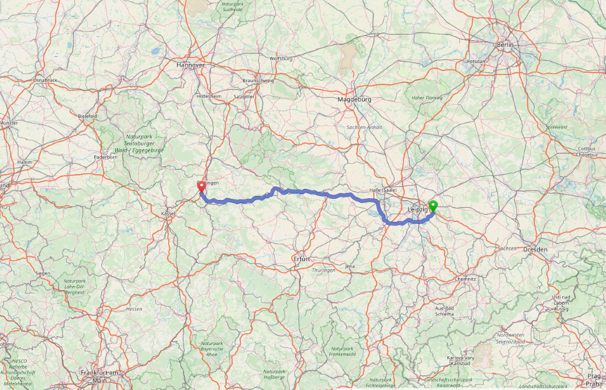Source: Open Street Maps

Figure 2: A38 in Germany, and Number of Residential Properties for Sale, 2007-2017
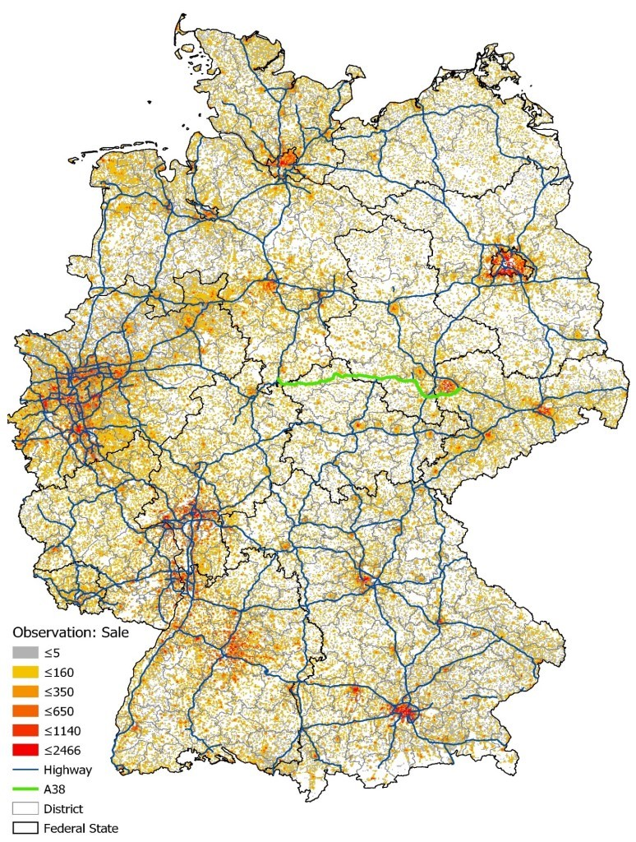

Figure 3: Average Residential Property For Sale Prices Within Germany, 2007-2017
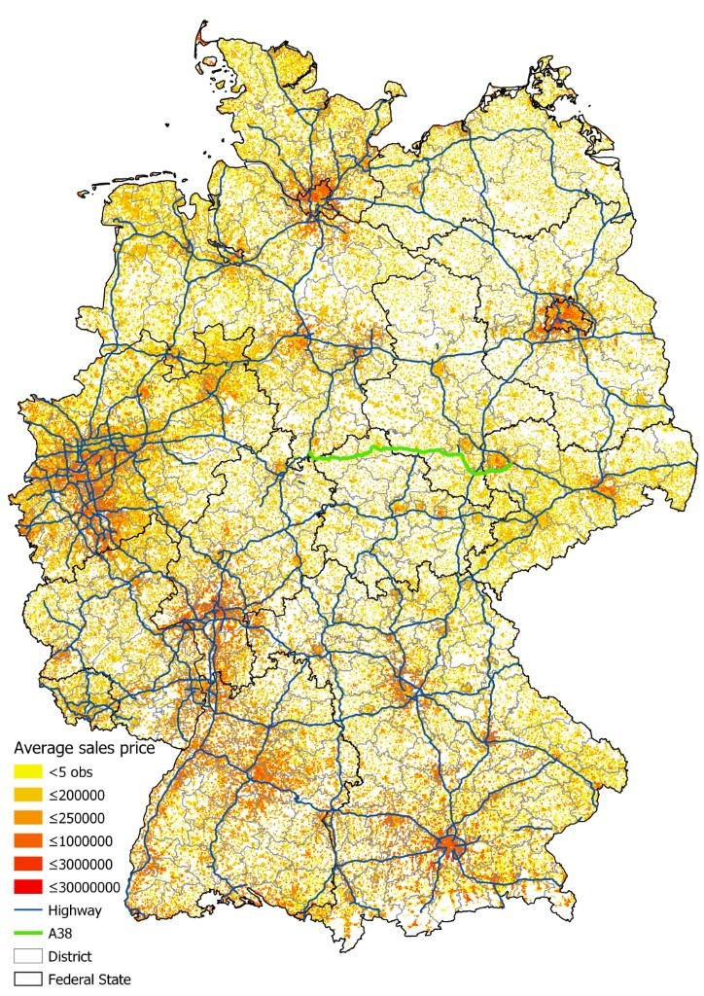
Figure 4: Highway A38 Completion and the “Previous Street”
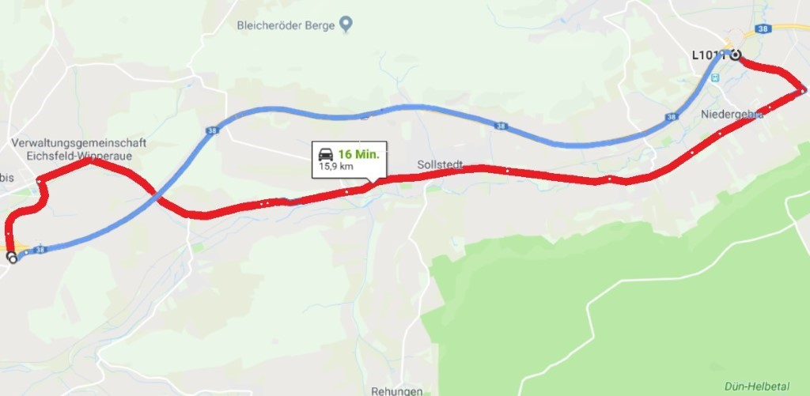
The blue colored part of the A38 (i.e., the alternative road to the “previous street”) was opened December 2009. The B80 (red route) was used before the opening (i.e., that is the “previous street” in Table 3, with 16,665 for sale properties nearby between 2007-2017).
Figure 5: Highway Extension
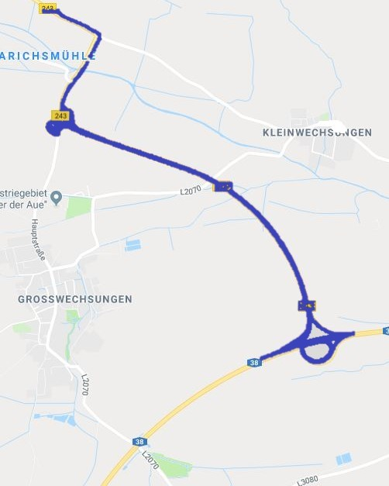
The blue colored part of the B243 leading up to the A38 was opened in December 2012. It is a Bundesstrasse (federal road) but in this part is like a highway (there are 10,532 for sale properties between 2007-2017 nearby this extension).

Figure 6: Drive Times to the A38 from Each Property for Sale (2007-2017)
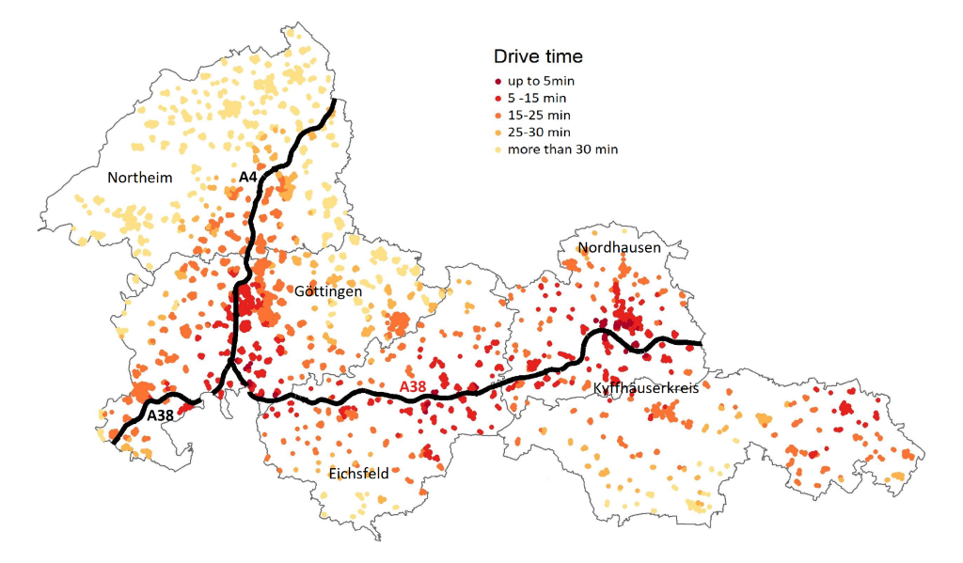
Figure 7: Euclidean Distance (meters) to the A38 from Each Property for Sale (2007-2017)
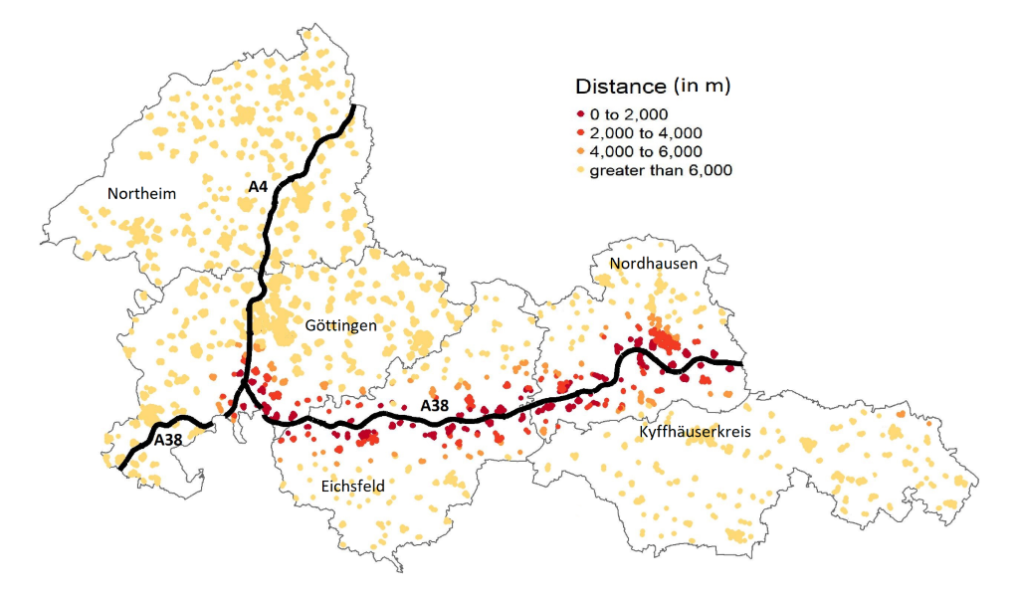

Figure 8: Log of Mean Price for Houses for Sale – Common Trends
Previous Street
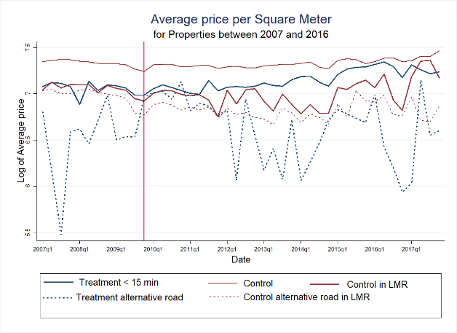
Highway Extension
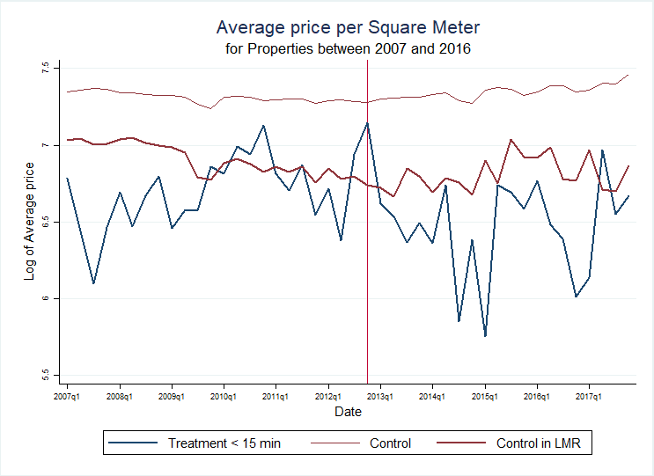
Source: RWI-GEO-RED, own calculation. LMR denotes “Labor Market Region”.

Corresponding author. Cohen acknowledges funding from the University of Connecticut’s Center for International Business and Education Research (CIBER) and Center for Real Estate and Urban Economic Studies (CREUES). Richard Weingroff provided helpful historical background information. The FDZ Ruhr at RWI-Leibniz Institute for Economic Research in Essen, Germany provided access to RWI-GEO-RED data that is based on RWI-GEO-RED data. Several individuals supported our efforts with valuable guidance and assistance, including Philipp Breidenbach, Lea Eilers, Felix Jung, Matthias Kaeding, and Sophia Völker. Thomas Bauer, Fabian Dehos and Philipp Jaeger provided helpful comments. Comments from seminar participants at RWI-Leibniz Institute for Economic Research are appreciated. Any errors are our own responsibility.
The German Autobahn system formed the model for the U.S. interstate highway system. When the U.S. General Dwight Eisenhower and the Allies conquered Germany at the end of World War II, the general was allegedly “impressed enough to come home and build our interstate highway system in response to what he’d seen” with Germany’s highway system (Wilkinson, 1988). This U.S. interstate highway system has become an integral part of various aspects of the U.S. economy, and it is widely believed that highways have impacted real estate values.
There are several studies focused on U.S. applications of highway impacts on employment, and a smaller number of academic U.S. studies focused on real estate impacts of highways. While data based on ImmobilienScout24 have been utilized extensively in real estate research, relatively few studies have been published on the German Autobahns’ impacts on real estate prices. U.S. highway studies have included Chandra and Thompson (2000), who examine the impacts of highways on economic development at the county level. They find that the impact of highways on industry varies, depending on which counties the highways pass through. While there are positive benefits from having a highway pass through the county, the nearby counties are worse off due to leaching of productive resources. Similarly, Baum-Snow (2007) uses information about the U.S. highway plans from the 1940’s to assess how these plans affect employment and population in more recent years, using Metropolitan Statistical Area (MSA) level data. They find that population decreased by roughly 18 percent in MSAs where highways pass through the central city. Cohen and Morrison Paul (2007) is one study that examines the relationship between U.S. highways infrastructure and property values, and they find that additional highways infrastructure enhances the “shadow value” of buildings and structures in the manufacturing industry.
http://en.rwi-essen.de/forschung-und-beratung/fdz-ruhr/datenangebot/
While Levkovich (2016) use a cutoff of 300 meters from the highway for their cutoff as noisy locations, in our sample, based on anecdotal evidence, we use 2000 meters as the cutoff for noisy locations. This is because we have observed significant noise, firsthand, at up to 2000 meters from infrastructure in Germany. Also, in the more rural areas surrounding these parts of the A38, relatively few houses have been for sale within 300 meters of the extended segments of the A38.
In the sales dataset, a small number of properties have negative values for their age, which is attributable to their being listed before their construction is completed. Some of the oldest properties are over 1,000 years old, however these constitute only a small number of properties and given the age of many buildings in Europe dating back several hundred years, these age values are not completely surprising.

